INDIAN SCHOOL AL WADI AL KABIR
Class: VII | Department : Computer Science | Year :2023-2024
Holiday Homework | Topic: HTML -Tables
1.Open Notepad and type html code for given output and save file using table.html.
2. using <table> tag create below table with following number of rows and columns
3. Apply table border using pixel of 10
4. Add Cellpadding of 20%
5. change the background color as teal and text color as yellow
6. Using Heading tag <h1> give the heading for the table and center it.

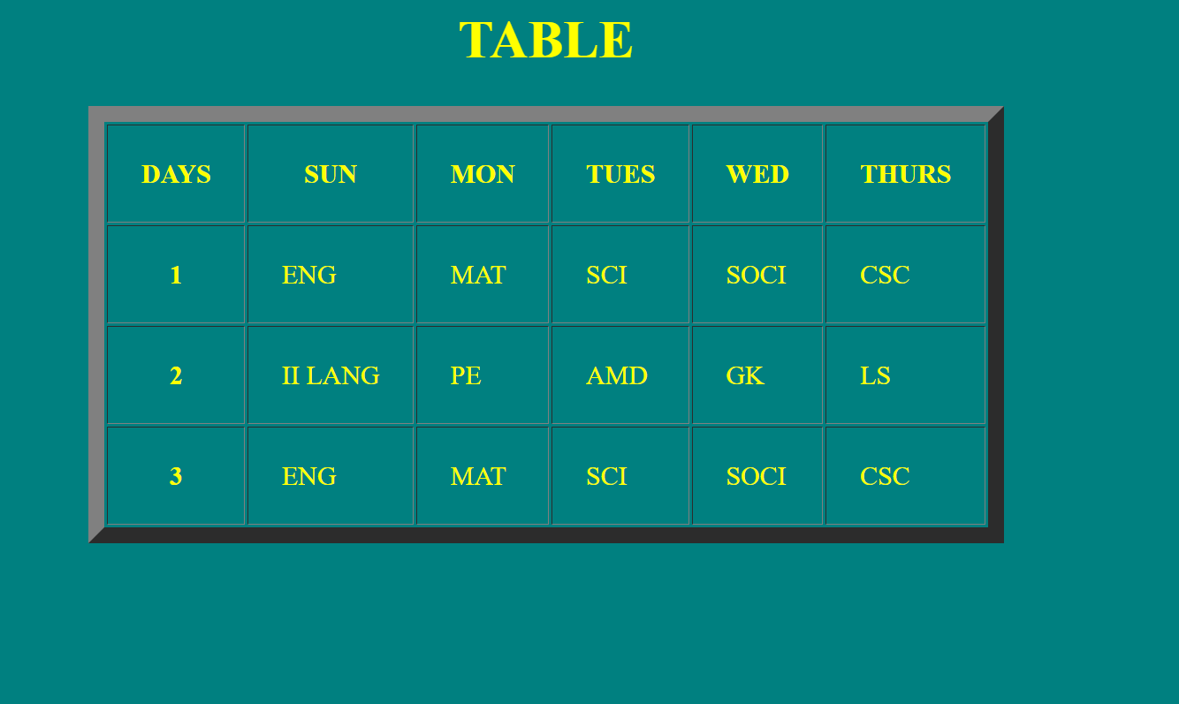
Note: Practice this worksheet , Evaluation will be done after holidays during practical session

